

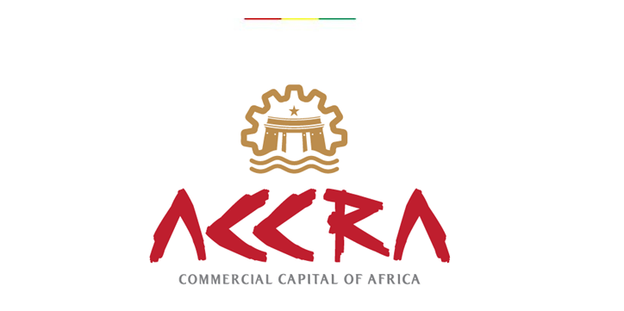

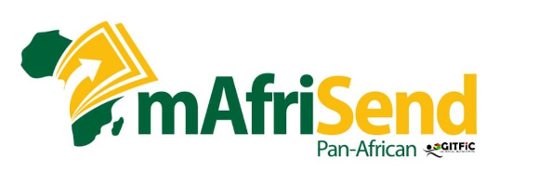

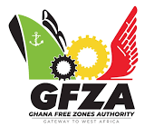

APPENDIX A: PROPOSED ACTION PLAN
Recommendations and Actions
7th Ghana International Trade & Finance Conference (GITFiC)
- Creation of African Single Currency
Issue Area | Recommendation | Action Points | Responsibility | Timeframes | Primary Target Beneficiaries
Involvement of Existing Monetary Unions | - promote research into progress and lessons by existing Monetary Unions such as WAEMU and CEMAC, to facilitate unified Single Currency | Signatories to AfCFTA to harmonise local financial rules with AfCFTA protocols. | - AU  - WAEMU  - CEMAC  - Regional Monetary Institutes | Periodically | Regional Monetary Institutes
Missed deadlines on implementation of single currency | - Develop National Programmes to meet macroeconomic convergence criteria within the shortest possible time. | Set time-bound targets on single inflation rate, budget deficit reduction etc towards an African single currency | - Heads of State  - Responsible ministries and government agencies | Urgently | Traders  Service providers and beneficiaries
Low sensitization on framework of PAPSS | - Sensitization on the PAPSS would need to be scaled up. (GITFiC avails itself in this regard) | PAPSS to engage African ministries and agencies including GITFiC | - National AfCFTA Implementation Offices  - PAPSS Council  - WAMI  - AfCFTA Secretariat  - GITFiC | Immediately | Traders’ Union  Industry players  Exporters  Financial Watchers & Analysts

- Trade Investment & Dispute Resolution
Issue Area | Recommendation | Action Points | Responsibility | Timeframes | Target Beneficiaries
Low participation of MSMEs in trade | Create a robust policy which operationalises the “Lead-Industry” concept where MSMEs  learn the innovation, culture and lessons of larger firms. (GITFiC avails itself in this regard) | Create policy for MSMEs to inter-act with larger firms | Responsible ministries and government agencies including GITFiC | ASAP | Trade Unions, Chambers of Commerce, Industry Associations, Exporters
Low sensitization on AfCFTA Protocol on Dispute Settlement Mechanism | - Enhance sensitization on functions of the AfCFTA Dispute Settlement Body. (GITFiC avails itself in this regard) | Resource National AfCFTA Implementation Bodies including GITFiC | AfCFTA Secretariat  National AfCFTA Implementation Bodies  GITFiC | At least, Once a year | State Parties
Low Trade Investment in Africa | - Encourage the development of Cross Border Special Economic Zones (CBSEZ) with emphasis on upscaling production and regional value chains. | Develop policy for establishment of Special Economic Zones, and adequately resource existing SEZs. | State Parties  Regional Economic Communities,  SEZs | Urgently | Traders  Investors
Low involvement of key stakeholders in AfCFTA | - Scale up involvement of stakeholders in trade in goods and services  - Encourage interaction with Traditional Authorities in procurement of land for investment and promotion of trade | AfCFTA activities should be industry-led.  Traditional Authorities | Associations of Industry across Africa  Private sector unions/associations including GITFiC | Immediately | Private sector
Slow commitment to Protocol on Free Movement on Goods and People | - African countries to redouble efforts to sign and ratify Protocol on Free Movement on Goods and People. | AU Commission to engage African Ministers of Trade (AMOT) and key stakeholders | AU Commission  AMOT | Immediately | All citizens of Africa

CONCLUSION
The 7th edition of the Ghana International Trade and Finance Conference (GITFiC) held at the Royal Senchi Hotel and Resort, Eastern Region - Ghana, brought to fore various issues which confront the implementation of an African Single Currency. This Action Plan, which contains relevant aspects of the issues and recommendations made at the Conference, is intended for consideration and study by policy initiators and implementators within the trade and finance ecosystem, academia and the various global economic blocs.
We are grateful for your sustained support and commitment to the vision of GITFiC and AfCFTA.

Distribution List:
All Heads of State of Africa
African Union
ECOWAS
Regional Financial Institutions
European Union
ASIAN
NAFTA or USMCA
WTO
APEC
G20
OECD
AfDB
AFREXIM Bank
Africa’s Business Community and others
The Press

