

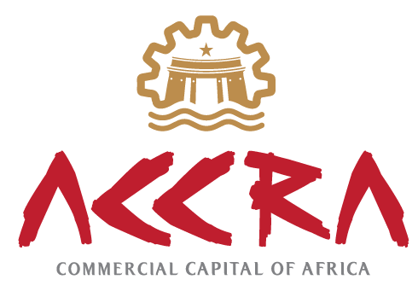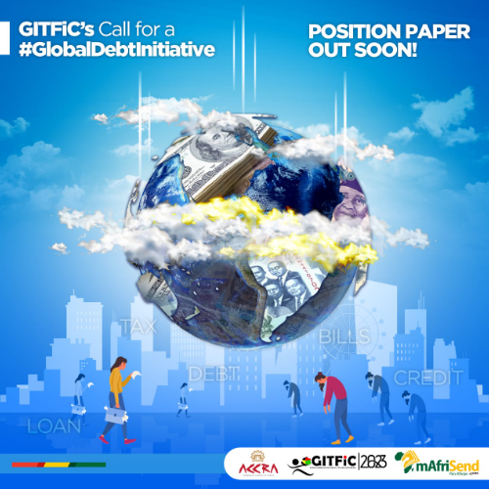

**Research Paper on: GLOBAL DEBT TO GDP POST COVID-19 (Sub-Saharan Africa)**

**Commencement Date: June, 2023**

**Completion Date: October 2023**

**The seemingly effects of COVID-19 on Global Debt to Gross Domestic Product on Economic Output; shedding light on the mechanisms through which these impacts have occurred.**

Researcher: Gerald Ekow Woode   
Director - Research, Policy and Advocacy  
Ghana International Trade & Finance Conference (GITFiC)  
P. O. Box Co 2814  
Krakue Street, Meridian, Tema – Ghana  
Office: +233 30-320-9055  
Email:  [infor@gitfic.com](mailto:infor@gitfic.com)

**Abbreviations:**

Advanced Economies (**AEs**), Emerging Markets (**EMs**), Low-Income Developing Economies (**LIDCs**), African Development Bank (**AfDB**), European Union (**EU**), Public Revenue Mobilization (**PRM**), Growth Stability and Sustainability (**GSS**), Ghana International Trade and Finance Conference (**GITFiC**), International Monetary Fund (**IMF**)

**Abstract:**

This paper examines the profound impact of the post-COVID-19 pandemic on the debt-to-GDP ratio in Sub-Saharan Africa and delves into the mechanisms through which these impacts have transpired. The COVID-19 crisis has presented unique challenges for economies worldwide, and Sub-Saharan Africa is no exception. The region has experienced significant disruptions in various economic facets, leading to a reassessment of its fiscal dynamics and debt sustainability.

The research paper employs a comprehensive analysis of economic data and policy responses to provide insights into the evolving debt landscape in Sub-Saharan Africa. We explore how the pandemic-induced economic shocks, including decreased economic activity, disruptions in global trade, and reduced government revenues, have amplified the region's debt burden. The study underscores the growing importance of domestic and international debt markets, as well as the impact of increased external borrowing on debt service costs. It emphasizes the need for prudent public financial management, including measures to optimize public investment and address unproductive spending patterns. This research contributes to a deeper understanding of the complex interplay between the COVID-19 pandemic, debt dynamics, and economic resilience in Sub-Saharan Africa, offering valuable insights for policymakers, international organizations, and stakeholders working towards the region's sustainable recovery and development.

**Introduction:**

The renewed interest in understanding the effects of global debt on economic output (GDP) has been spurred by the COVID-19 pandemic. This pandemic caused a significant global economic downturn, as reported by Aizenman and Ito in 2020 (Aizenman and Ito, 2020). The relationship between global debt and macroeconomic variables like GDP growth and interest rates, et al., has been a longstanding policy concern dating back to the 1990s. An increase in debt can be a result of various factors, including increased government spending, reduced tax revenues, or other fiscal changes. However, there is little consensus on the direction and magnitude of the impact of increased debt on real GDP. Analyzing global debt sustainability is a critical aspect of the International Monetary Fund's work with its member countries, as it is essential to understand how changes in global debt will affect real GDP in the short to medium term.

The response to the pandemic, including expansionary fiscal policies, led to a significant increase in global debt levels worldwide. In 2021, the global debt-to-GDP ratio was projected to reach 98.8 percent, compared to 83.7 percent in 2019 before the pandemic. Advanced Economies (AEs) were expected to see their average global debt-to-GDP ratio rise from 103.7 to 122.5 during the same period, with smaller increases projected for Emerging Markets (EMs) and Low-Income Developing Economies (LIDCs), going from 54.8 to 65.1 and 44.2 to 48.5 percentage points, respectively. While policies that increase global debt may stimulate short-term growth, the increased debt-to-GDP ratios could potentially offset the fiscal stimulus's effects in the medium term, potentially slowing down the post-pandemic recovery.

African governments have mainly borrowed funds to finance stimulus packages, supporting vulnerable populations, struggling businesses, innovative educational solutions, and healthcare infrastructure. International and regional financial institutions such as the World Bank, IMF, African Development Bank (AfDB), and European Union (EU) have responded through debt relief measures and restructurings. The fiscal and monetary responses of sub-Saharan African countries and these financial institutions will have significant implications for indebtedness, debt servicing capacity, and debt sustainability in a broader sense.

Debt was already a growing concern in all income groups in African countries before COVID-19, and the pandemic has exacerbated this issue. African nations have been increasingly borrowing in global financial markets in recent years, creating both opportunities and challenges. Rising debt levels have been accompanied by higher debt service costs, but countries have not necessarily improved their ability to finance these obligations. Failure to meet debt service obligations could lead to credit rating downgrades, higher future costs, pressure on foreign exchange reserves, domestic currency depreciation, and the risk of being excluded from the market, along with negative reputational consequences.

Estimates indicate that the global economy contracted by 3.3% in 2020, with projected growth of 6.1% in 2021 and a projection of 3.6% in 2022 (International Monetary Fund, 2021, 2022). African countries faced a GDP loss estimated at between US$145.5 billion and US$189.7 billion in 2020 (African Development Bank, 2020, 2021). This report by the Ghana International Trade and Finance Conference – GITFiC focuses on the impact of the post-COVID-19 pandemic on debt to GDP in sub-Saharan Africa, shedding light on the mechanisms through which these impacts have occurred.

During economic crises, such as the COVID-19 pandemic, GDP often contracts due to reduced economic activity, disruptions in supply chains, decreased consumer and business confidence, and other factors. Governments typically respond to such crises with increased spending to stimulate the economy, support affected sectors, and provide social safety nets. This increased spending, coupled with a decrease in GDP, can result in a higher Debt-to-GDP ratio. However, as economies recover, GDP growth can outpace the growth of debt, leading to a decline in the Debt-to-GDP ratio. Economic recovery may bring increased revenue, improved business conditions, and reduced reliance on emergency spending measures. In this scenario, the ratio may stabilize or decrease over time. It's important to monitor the trajectory of the Debt-to-GDP ratio to assess the fiscal health and sustainability of a country's debt levels. Sustainable economic policies and prudent fiscal management are crucial for managing debt dynamics and ensuring long-term economic stability. Policymakers often aim to strike a balance between using fiscal stimulus during crises and implementing measures to ensure fiscal sustainability in the recovery phase.

**Why Debt to GDP Ratio**

The COVID-19 pandemic has had significant economic implications globally. In the case of Sub-Saharan African countries, the region experienced disruptions in trade, a decline in commodity prices, reduced tourism, and other economic challenges. The pandemic led to a contraction in economic activities, resulting in increased government spending to address health emergencies and support affected sectors. To finance the increased spending required to combat the health and economic effects of the pandemic, many governments in Sub-Saharan Africa resorted to borrowing. Governments may have borrowed domestically and internationally to fund healthcare infrastructure, social safety nets, and economic stimulus packages.

The focus on the Debt-to-GDP ratio suggests a concern about the sustainability of the debt levels in these countries. High levels of debt relative to the size of the economy can be a cause for concern, as it may lead to debt distress and repayment challenges. Monitoring the Debt-to-GDP ratio is a key indicator of a country's ability to manage its debt obligations. A high Debt-to-GDP ratio can limit a government's fiscal policy options. It may constrain the ability to implement new stimulus measures or respond effectively to future economic shocks. Research in this area may assess the implications of high debt levels on the fiscal space of these countries. High levels of debt can affect a country's creditworthiness and may reduce investor confidence. If investors perceive a country as having unsustainable debt, they may be less willing to provide financing, leading to higher borrowing costs.

Understanding the Debt-to-GDP ratio is crucial for countries seeking international assistance or debt relief. Organizations like the International Monetary Fund (IMF) and the World Bank often consider a country's debt levels when providing financial assistance or designing debt relief programs. In summary, the research on the Debt-to-GDP ratio of selected sub-Saharan African countries after COVID-19 is likely driven by a combination of economic challenges, increased government borrowing, concerns about debt sustainability, and the need for informed policy decisions to navigate the post-pandemic economic landscape.

**Debt to GDP in Africa:**

A significant post-pandemic risk facing African nations is the combination of external financing challenges and high debt levels. Many African countries have already reached their maximum threshold of public debt (in the case of Ghana, 90%–92% of GDP), which, in turn, limits their ability to increase spending and can hamper economic growth prospects. The consequence of reduced growth prospects is a diminished capacity to service public debt. Additionally, the decline in foreign reserves, remittances, capital inflows, and currency depreciation further constrains the ability of many African nations to meet their foreign currency-denominated debts. Ghana and Nigeria face particularly challenging circumstances in the aftermath of the COVID-19 pandemic. Ghana’s debt-to-GDP ratio, as aforementioned, is about 92%, with debt-servicing costs consuming over 50% of annual revenues. In Nigeria, although debt levels are relatively low and expected to increase only moderately, low revenues mean that debt interest costs are predicted to reach 37% of revenues by 2026, up from 21% in 2019. Consequently, it appears prudent for these countries to consider implementing fiscal consolidation measures, as is rightly so in the case of both countries, as they are already in place. The four other largest economies in the region, Cote d’Ivoire, Ethiopia, Kenya, and Tanzania, are also expected to have debt-servicing costs exceeding 10% of revenues by 2026, making it advisable for them to explore fiscal consolidation options.

In 2019, the average government debt as a percentage of GDP in the Sub-Saharan Africa (SSA) region was 50.4%, up from 48.5% in 2018, indicating increased investments in infrastructure across the region. However, these figures rose to 56.6% in 2020 and 57.8% in 2021, primarily due to the impact of the COVID-19 pandemic. In some countries, this debt increase is more than double their annual budgets. The expenses related to managing the spread of the COVID-19 virus, coupled with decreased revenues due to lockdowns and a general economic slowdown, are placing substantial pressure on government finances across the world, most especially with a stronger impact on the African continent. As a result, nearly all economies in the region are running larger fiscal deficits (IMF, April and October 2020). The global debt landscape in 2020 witnessed a significant surge during the pandemic. The global debt-to-GDP ratio climbed to 356%, with global debt reaching US$281 trillion by the end of 2020. These figures underscored the exceptionally high levels of global debt in 2020, raising concerns among many analysts about a potential global debt crisis; hence, the call by the Ghana International Trade & Finance Conference – GITFiC for A GLOBAL DEBT INITIATIVE is in the right direction and worth supporting by all member states and global citizens.

The COVID-19 pandemic had a substantial impact on the global economy, leading to the collapse of financial markets, business closures, and a halt in economic activities due to rising COVID infections, deaths, and movement restrictions in 2020, 2021, and, in some cases, 2022. Many countries ramped up fiscal spending to mitigate the pandemic's economic fallout. Countries with limited budgetary resources relied on loans from wealthier nations and multilateral organizations to rescue their economies from the pandemic's consequences. Wealthier nations or those with ample financial resources quickly rebounded from the COVID pandemic, as they could afford to secure and distribute large quantities of COVID-19 vaccines. In contrast, poorer countries experienced slower economic recoveries, partially due to their limited access to COVID-19 vaccines.

The IMF estimates that the African region requires an additional $345 billion for a full recovery from the pandemic between 2021 and 2023. Many African countries, including Zambia, Angola, Ghana, Nigeria, Cote d'Ivoire, et al., are in a precarious financial situation but due to timely interventions from the IMF, these economies could have grounded to a total halt. China stands as the largest lender to African nations, having extended over US$143 billion in loans to Africa within the last 2 decades through its government, banks, and industries, according to the China Africa Research Initiative. Approximately ten African countries are grappling with serious debt issues with China, such as Djibouti, Ethiopia, Kenya, Angola, and Zambia. The substantial external debt burden incurred by African nations complicates the region's prospects for COVID-19 recovery. Without debt forgiveness or relief, the debt crisis threatens to undermine the economic progress the African continent has been demonstrating (Chandler, 2020).

The impact of COVID-19 has exacerbated Africa's sovereign debt challenges. While the debt-to-GDP ratio for African countries averaged below 60% before the COVID-19 crisis, it surged to over 70% in 2020 and, in some cases, over 100% post pandemic. Seven countries, namely Angola, Cabo Verde, Republic of Congo, Eritrea, Mozambique, Sudan, and Zambia, have particularly high debt-to-GDP ratios exceeding 100% (International Monetary Fund, 2020a). Africa's gross government debt more than doubled in 2020, increasing from a low of 32% of GDP in 2008. This growth is partly attributed to greater access to international credit markets and diversification of creditors (Organisation for Economic Co-operation and Development, 2020). Similar trends have been observed across various creditor and debtor types. The number of African countries at high risk of debt distress or already in distress increased from 8 in 2015 to 16 in 2019 and 17 in 2020 (International Monetary Fund, 2020). The pandemic's impact on Africa's sovereign debt is a significant concern, given the evolving risk landscape.

**Figure 1.1: Pre COVID 19 Debt to GDP**

**Source:** International Monetary Fund

**Figure 1.2: Post COVID 19 Debt to GDP**

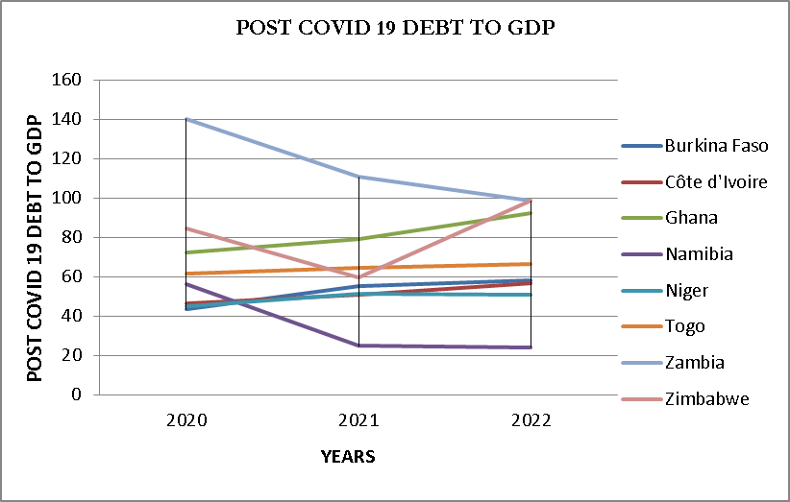

**Source:** International Monetary Fund

**Key Findings by the GITFiC:**

Debt levels in sub-Saharan Africa have significantly increased since the onset of the COVID-19 pandemic. The region witnessed a 4.5 percent rise in "pandemic debt," which refers to debt acquired beyond initial projections by the IMF of 55.4 percent in 2019 to 60.3 percent in 2021 due to the crisis. Notably, Highly Indebted Poor Countries (HIPC) saw substantial increases in pandemic debt, with levels exceeding projections by 8.5 percent (59.5 percent in 2019 to 63.9 percent in 2021). Developed countries primarily took on planned debt and borrowed from both private and official credit markets (bilateral or multilateral). In contrast, developing countries, largely excluded from private credit markets, relied on official credit to accommodate the surge in mostly unplanned debt. The study also highlighted the growing importance of domestic bond markets for private borrowing, while euro bond issuance remained relatively limited. Despite assuming significant pandemic debt, developing countries experienced less severe drops in GDP compared to their developed counterparts, emphasizing the need for financial sector development, improved public-sector financial management, and measures to address financial leaks, curb illicit flows, and boost domestic resource mobilization. Looking ahead, this paper by the GITFiC, argues that the recovery and debt sustainability in sub-Saharan Africa hinge on two key factors: the success of the African Continental Free Trade Agreement (AfCFTA) and the involvement of private partners in debt restructuring.

Economic recovery is crucial for the millions of informal workers affected by the pandemic's job losses and the corresponding revenue levels linked to their transition into the formal economy.

While Africa may have been spared the worst health impacts, the pandemic has caused significant socioeconomic repercussions. The continent had shown relatively robust growth from 2009 to 2019, with Ghana’s growth hovering above 6%, even in the face of challenges like the global financial crisis and fluctuations in commodity prices during those periods. However, COVID-19 hindered Africa's growth and progress and wiped off the successes chalked. According to the African Development Bank (AfDB, 2021), the continent saw a 1.5% decline in GDP growth in 2020 (the COVID-19 era), its lowest in the past two decades. This translated to a reduction of US$165 billion in GDP compared to the pre-COVID-19 estimate for 2020, which was US$2.59 trillion. These losses persisted in 2021, though to a lesser extent, reflecting a partial recovery. Estimated GDP losses in 2021 range from US$27.6 billion to US$47 billion, relative to the projected GDP of US$2.76 trillion without the impact of COVID-19. Africa's real GDP growth was anticipated to reach 4.2% in 2022, surpassing pre-COVID-19 levels.

The pandemic has affected Africa's economic outlook through multiple channels, including commodity prices and trade, travel and tourism, and financial flows. The most severely impacted countries are those with weak health systems and economies heavily reliant on service sectors like tourism, international trade, and commodity exports (AfDB, 2020). Nations with high debt burdens and those dependent on international financial flows have also been adversely affected (AfDB, 2021).

Expansionary fiscal spending is expected to double the continent's already high fiscal deficits. Despite Africa's fiscal consolidation policy stance, fiscal deficits persist due to challenges in public revenue mobilization (PRM). Spending on healthcare, social safety nets, and measures to sustain productivity amid reduced public revenues, driven by COVID-19, have exacerbated Africa's existing high fiscal deficits. Fiscal deficits increased from 4.3% and 4.7% of GDP in 2018 and 2019 to 7.2% in 2020 before moderating to 5.3% in 2021. Projections by the IMF indicate further easing to 4.7% in 2022 and 4.0% in 2023. This highlights the limited fiscal space available to African countries for the necessary policy responses to address the COVID-19 crisis.

**Recommendations by the GITFiC:**

The economic repercussions of COVID-19 will have long-lasting effects, necessitating innovative strategies to prevent a potential wave of future defaults however, since the beginning of 2023, several African countries went deep into these tangent of debt repayment defaulting hence, the rush for policy credibility through robust structural adjustments offered by the International Monetary Fund. While the **G20's** recently introduced common framework for debt treatments is a significant and positive step, more actions are required to assist countries in averting a debt crisis, while also creating room for COVID-19 response and post-pandemic recovery. We at the Ghana International Trade & Finance Conference – GITFiC dare say; Africa and the rest of the world are already in a Global Debt Crisis hence the urgent need for a **#GlobalDebtInitiative**. Debt interventions should aim to boost liquidity. The GITFiC recommends the following;

1. The need to maximize effectiveness of current efforts. In the face of an unprecedented global health and economic crisis, it is crucial to ensure that all countries have the capacity to safeguard their populations and economies. This might entail more extensive debt service moratorium initiatives. This can be compassed in our call for a **#GlobalDebtInitiative**.
2. There's a need to expedite the establishment of bold new initiatives. African countries, in collaboration with their creditors, should come up with inventive solutions that go beyond temporary suspensions, such with China, the Paris Club et al. While the **G20's** proposed common framework for debt treatments is a positive initial step, more can be achieved. Ideas such as creating a debt exchange mechanism through a Special Purpose Vehicle (SPV), enhancing global liquidity by generating new **Special Drawing Rights (SDRs),** or improving the utilization of **debt swap mechanisms** should be reconsidered and adjusted as necessary to overcome political obstacles.
3. African Countries should redefine what constitutes debt sustainability. The COVID-19 crisis has revealed the limitations of existing criteria for prudent debt practices and sustainable development. These standards need to be improved and adapted, with the input of all parties involved, including creditors and debtors.
4. Reforming the international debt architecture is essential. Given the significant shifts in global debt dynamics in recent years, the framework for restructuring sovereign debt should align with the current situation. An assessment by the IMF of recent debt restructurings showed that they often came too late and were insufficient, frequently failing to restore debtor countries to debt sustainability and market access.
5. Enhancing public investment and public financial management is crucial. In Africa's history of debt, increased borrowing has often not corresponded to more productive spending. Governments must take decisive steps to reduce unproductive, non-essential expenditures and low-priority capital investments, including subsidy reductions and streamlining wage bills. Given limited fiscal space, governments must carefully target the most productive uses for public investment, directing fiscal policies towards sustainable growth and shared prosperity.

**Conclusion:**

Debt suffocation, as recently seen in several economies in Africa, can never be said to be self-imposed. We at The GITFiC, however, admit that some of these countries already had high debt levels pre-pandemic; most of these debts were sustainable and were within control. The impact of the COVID-19 pandemic and the highly commendable quest by governments to place their citizens as priorities initiated several reliefs in the form of stimulus packages and industrial growth incentives, feeding the absolute vulnerable, protective gear, medications, et al., hence the extra borrowing, which ballooned.

The era of freebies has come to an end, as the World Health Organization declared the pandemic as over. The need for governments to recuperate and steer their various economies towards growth, stability, and sustainability (GSS) will also mean that citizens will have to adjust to the implementation of fiscal measures to achieve these results. These may include the introduction of new levies and taxes, strict compliance in all sectors, and cutting down on expenditures, among other measures.

The Ghana International Trade & Finance Conference – GITFiC will dedicate the entire year 2024 to a global campaign with A CALL TO ACTION with the hashtag #A Call for GlobalDebtInitiative. This call will seek permission from the highest office in Ghana, proceed to the ECOWAS sub region, the African Union, and expand to the European Union, the Americas, and Asia. The African Union and the United Nations are expected to partner on this call through our position paper yet to be released after extensive consultations.

Africa still has a high potential to grow within the shortest possible time, especially with the implementation of the African Continental Free Trade Area – AfCFTA, for which we at the Ghana International Trade & Finance Conference have been key stakeholders in the sensitization, education, and introduction of several citizens on the African continent and beyond. We have done so by authoring the first ever approved and endorsed book on the AfCFTA titled; Actualising the African Economic Vision A Practical Handbook on the AfCFTA, for which over 5,000 copies have been distributed and are still ongoing. We have held conferences, forums, and seminars so far in four African countries and five regions of Ghana. We have dedicated four of our last annual conferences to the AfCFTA by bringing to the stage continental top-notch speakers and panellists to practically advance education and relevant information for the various business communities.

We have extensively delved deep into the Pan-African Payment and Settlement System - PAPSS, a prerequisite to the success of the implementation of the AfCFTA. We have also reviewed the AfCFTA, a year after implementation and have established the AfCFTA Tertiary Clubs in four of Ghana’s prestigious schools namely; University of Ghana, Kwame Nkrumah University of Science and Technology, University of Development Studies and the All Nations University. Plans are underway to expend this all other African countries.

Accra, the capital of the Republic of Ghana, was declared the commercial capital of Africa by the Ghana International Trade & Finance Conference – GITFiC in October 2020. This was honorably done by His Excellency the President of Ghana, Nana Addo Dankwa Akufo-Addo, through the then Senior Minister of the Republic of Ghana, Hon. Ing. Yaw Osafo-Maafo. He was joined by the then-mayor of Accra, Hon. Mohammed Adjei Sowah. Several reasons accounted for this rightful declaration but what stood out was the sighting of the headquarters of the African Continental Free Trade Area – AfCFTA in Accra. **END**

**Reference:**

Aizenman, J., & Ito, H. (2020). *US Macro Policies and Global Economic Challenges* (No. w28232). National Bureau of Economic Research.

Chandler, B. (2020). COVID-19 & African Debt: Further distress or the beginning of a new

paradigm? The Mo Ibrahim Foundation.

International Monetary Fund (2020). World Economic Outlook, April 2020: The Great Lock-down. Technical Report April, Washington DC, 2020.

International Monetary Fund. 2021. *WORLD ECONOMIC OUTLOOK UPDATE JULY 2021 Fault Lines Widen in the Global Recovery*.

African Development Bank. (2020). African economic outlook 2020 supplement. African Development Bank.

African Development Bank. (2021). African economic outlook 2021: From debt resolution to growth: The road ahead for Africa. African Development Bank.