**DISTRIBUTIONAL IMPACT OF AFRICA CONTINENTIAL FREE TRADE AREA (AfCFTA) ON POVERTY REDUCTION & EMPLOYMENT IN SUB-SAHARAN AFRICA-GITFIC JUNE 2021**

***Mr. Gerald Woode***

***Lead-Research Fellow (Policy and Advocate)***

***Ghana International Trade & Finance Conference***

[**gerald.woode@gitfic.com**](mailto:gerald.woode@gitfic.com)

**1.0 INTRODUCTION**

The African Continental Free Trade agreement (AfCFTA) one of the largest free trade areas in the world has been described as a ‘game changer’ and a springboard for African economies to improve intra-trade among its over 1.3 billion citizens. Since the creation of AfCFTA in 2018, the community of African countries has shown high commitment and determination to harness the benefits of a trade liberalized system. This is evidenced by the fact that 37 countries have now deposited their instruments of ratification, with Algeria being the latest to do so few days ago.

While the operational phase of the AfCFTA was launched in 2019, and start of trading began on 1 January 2021, one of the AfCFTA’s strategic objectives as enshrined in the enabling Agreement is to “promote and attain sustainable and inclusive socio-economic development, gender equality and structural transformation of the State Parties”. This objective can only be feasible if efforts are made to reduce poverty and boost employment. It is on this score that the World Bank in its analysis observed that by 2035, the AfCFTA would help raise 30 million people out of severe poverty and 68 million people out of moderate poverty,[1] through the progressive elimination of tariffs and elimination of non-tariff barriers to trade and investment.

Employment is a crucial issue for many countries on the continent. Various studies have identified that a large proportion of the workforce is either unemployed or under-employed. A case in point is the report by the World Bank which stated that Ghana is faced with 12% youth unemployment and more than 50% underemployment, which are both higher than overall unemployment rates in Sub-Saharan African countries. For various reasons, the issue of youth employment on the African continent is critical. First, the social return on jobs for youngsters is particularly important for the region's future living standards, productivity, and social cohesion. Policymakers are aware of this, as well as the consequences of young people not working or working in low-wage occupations, thus youth employment is a top concern almost everywhere. The second reason for the high stakes is demographics. SSA is the world's youngest region, with a substantial youth bulge that will continue to grow in the future. Poverty is often defined as a lack of economic resources with poor social implications, yet surprisingly little is known about the impact of economic hardship on social outcomes. Poverty, according to the most widely accepted definitions, is defined as a lack of economic resources that has detrimental social repercussions. This is, in fact, a dominant stance in current poverty theories and it also has a long history[2].

The phrase employment refers to the state of being employed. Typically, it is the relationship between an employer and an employee. People's employment differs in that some are employed for the full year, while others are working for only a portion of the year. Employment is a connection between two parties, usually based on a contract in which work is paid for, where one party, which may be a business, for-profit or not-for-profit organization, co-operative, or other entity, is the employer and the other is the employee.

As already highlighted, the advent of the AfCFTA is expected to be a paradigm shift, as the implementation would boost member countries' wages and well-being (World Bank Group, 2020). This position is reinforced by the findings of Abrego et al. which stated that the trade liberalization system under the AfCFTA could result in long-term income gains of up to 7% for member countries[3]. The research also considered the measurement of welfare reforms and found benefits of up to 2.1 percent. Per the World Bank Group (2020), Côte d'Ivoire and Zimbabwe are at the top of the list, with income increases of 14 percent each. At the low end, a few countries, such as Madagascar, Malawi, and Mozambique will see real income gains of about 2%. Research findings from Anyanwu on the impact of intra-African trade on youth unemployment in 46 African nations from 1980 to 2010 revealed that a high degree of intra-African commerce lowered the aggregate of youth unemployment in Africa for both young men and young women[4].

This paper will explore the statistical levels of poverty and unemployment on the African continent, with particular focus on the Sub-Saharan region. It also considers how the implementation of the AfCFTA would reduce poverty rates and unemployment in the various economies.

**2.0 LITERATURE REVIEW**

**2.0.1 The nexus between Poverty and Unemployment**

Although this paper focuses on AfCFTA's impact on employment, it is important to remember that Africa's high poverty rates make job creation much more urgent. Employment is not a means of pursuing career goals for the poor; it is a means of making a living in order to survive. Unemployment is one of the main determinants of poverty in Africa, according to empirical micro - economic studies. Due to the lack of reliable employment data in Africa, it is difficult to find similar quantitative micro - economic studies of unemployment. Using available data, this section addresses the main characteristics of poverty and unemployment in Africa.

**2.0.2The Magnitude of Poverty in Africa**

Despite a steady rise in real GDP in Africa over the last ten years, Africa is the only area where poverty has increased over the last three decades[5]. This is in direct contrast to the global trend, which indicates a significant decline in poverty rates. In 2003, Africa's poverty rate was 17 percent higher than South Asia, the world's second poorest geographical bloc.

As a result, poverty has emerged as Africa's most pressing development problem, with international agreement that eradicating poverty should be the primary goal of all development efforts on the continent. Employment is, without a doubt, the most effective means of eradicating poverty in Africa whether wage workers or self-employed African household members earn a living. This is especially critical given the limited number of alternative assets on which they can depend. Unemployment, underemployment, and poor labor returns may all be considered immediate causes of poverty in Africa. As a result, policies that promote economic development and job creation are expected to be "necessary for any poverty reduction strategy". Despite some recent development, poverty rates (at the lower-bound national poverty line) are anticipated to fall from 40% of the population in 2015 to 33% in 2030. In Sub-Saharan Africa, poverty (as calculated by the headcount ratio) remained high, whereas it fell in other parts of the world. In 2018, 40 percent of the population of Sub-Saharan Africa lived on less than $1 per day, significantly lower than in 2015. However, the proportion of the world's population living on more than $1.90 per day has increased to 53 percent in 2018 as compared to 20 percent of previous years. Sub-Saharan Africa now has a headcount ratio of $1 per day that is 17 percentage points higher than the next poorest geographical bloc, South Asia.

**Figure 2.1: Extreme Poverty ($1.90 a day 2011 PPP, % of population)**

**Source:** African Development Bank, 2020

**Figure 2.2: Moderate Poverty ($3.20 a day 2011 PPP) (% of population)**

**Source:** African Development Bank, 2020

The diagram above shows the poverty headcount ratio at $3.20 a day (2011 PPP) for selected countries in Sub Saharan African.

In Cameroon, poverty remains high in 2014, at 37.5 percent (using the national poverty level); just marginally lower than 39.9 percent in 2007 and 40.2 percent in 2001. The slow development is due to opposing regional poverty trends: a significant decline in poverty in the eastern, western, central, and coastal regions of Cameroon has been offset by a rise in poverty in the northern regions. The poverty map recently set up by the government showed an increase in poverty in the Far North, North West and South West regions ranging from 77%, 57%and 21% in 2019 respectively compared to 74%, 55% and 18% in 2014 while it slightly decreased or remained stagnant in other regions. The widening difference is caused by a concentration of investments in the two most populous metro areas, as well as the emergence of security concerns in the north region of Cameroon. Because of fast population increase, the number of poor people reached 8.3 million in 2014, with 90% living in rural areas and 69 percent in the North. In 2014, nearly 45 percent of the population was poor, living on less than $3.20 per day, and about 37 percent was multi-dimensionally poor. Growth's impact on poverty reduction is attributed to increased inequality, with the Gini index rising significantly between 2007 and 2014 from 42.8 to 46.6 per cent). Much of this increase can be attributed to growing economic gaps between rural and urban areas, as minimal well as between the northern regions and the rest of the country.

In Kenya, the proportion of the people living in poverty has decreased from 28.3 percent in 2019 to 27.3 percent in 2020. The majority of the poverty reduction can be attributed to success in rural areas, as poverty fell from nearly 50% in 2005/06 to 38.8% ten years later. Despite a slowdown in growth induced by the global COVID-19 pandemic, the international poverty headcount rate is predicted to fall further, but at a slower rate, to 33.1 percent in 2020 and 32.4 percent in 2021. Poverty at $3.20 per day per figure 2.2 above is not expected to increase but the depth of poverty may worsen because of the decline of incomes of retailers and informal sector workers who are already poor or vulnerable and will fall further below the poverty line.

Ghana enjoyed strong economic growth and poverty reduction; however the rate of poverty reduction has decreased in recent years and is now negligible after 2012. Ghana reduced poverty by half over the past decade, with minimal increase in income disparity. By 2012, it had fallen to 12.0 percent at 2011 PPP $1.90 per person per day, which is not only lower than the Sub-Saharan African average, but also lower than the lower-middle income countries' average. However, the poverty reduction rate increased significantly in 2016 to 13.3 percent lower than not only the mean poverty rate of Sub-Saharan Africa but also the mean poverty rate of middle-income countries.

Poverty in Tanzania has decreased from 26.4 percent in 2018 to 25.7 percent in 2020. Poverty reduction was driven by a decrease in rural poverty while urban poverty remained stable. Tanzania poverty rate was at a level of 49.4 per cent in 2017, down from 49.6 percent in 2011.

Poverty in Zanzibar (which performs its own poverty surveys) fell from 34.9 percent in 2009/10 to 30.4 percent in 2014/15.The number of impoverished individuals increased as population growth remained stronger, exceeding the rate of poverty reduction from 2011 to 2018. In 2018, around 14 million Tanzanians were poor, up from 12.3 million in 2011-2012. Using the international extreme poverty threshold of US$ 1.90 per day, Tanzania's poverty rate has stayed stable at 49 percent between 2011/12 and 2018, with 27.6 million people classified as poor.

According to the most recent official survey conducted by the National Bureau of Statistics (NBS) in Nigeria, the extreme poverty headcount rate in 2018 was projected to be 39.1 percent, based on the international poverty standard of $1.90 per person per day (2011 PPP). The extreme poverty headcount rate was expected to be 40.1 percent in 2019, reflecting little increase in the incomes of the poorest half of the population over the previous decade. In recent years, the anticipated poverty trend has closely tracked macroeconomic trends. The importance of oil export profits, a high population growth rate, and regional economic disparities have diluted growth's welfare effects. Nigeria has struggled to re-invigorate broad-based growth after the dramatic drop in oil prices in late 2014 and the resulting downturn in the economy.

Malawians living below the international poverty level of $1.90 per day have decreased somewhat from 71.7 percent in 2010 to 70.8 percent in 2016. Furthermore, population growth has raised the number of persons living below the international poverty line by 10.8 million to 12.1 million. Furthermore, more than 90% of the poor live in rural areas, where poverty has marginally increased. The proportion of the population living below the national poverty line has risen slightly, from 50.7 percent in 2011 to 51.5 percent in 2016. Rural poverty grew from 2010 to 2016 as a result of recurring shocks such as drought and flooding, and it is concentrated in the South. Poverty decomposition reveals that between 2010 and 2016, a lack of sustained economic growth hampered poverty reduction, although a more equitable distribution aided the favorable poverty trend.

During 2016, Namibia's poverty rate was more than half; however poverty incidence remains relatively high for an upper middle-income country. In 2015/16, 17.4 percent of Namibians lived below the national poverty line, down from 28.7 percent in 2009/10 and 69.3 percent in 1993/94. However, the prevalence of poverty was expected to rise in 2018 per statistics. Using the 2011 PPP $1.90 per person per day international poverty level, the poverty rate declined from 22.6 to 13.4 percent between 2009 and 2015. In 2015, the equivalent poverty rate was 29.6 percent at the 2011 PPP ($3.20 per person per day), while it reached 50.1 percent at the 2011 PPP $5.50 per person per day.

**2.0.3 Trends of Unemployment in Sub-Saharan Africa**

Unemployment remains one of the most serious developmental challenges confronting all countries around the world. Governments have fought and continue to fight this phenomenon because of the negative effects it has on their economies. Africa's and more specifically, Sub-Saharan Africa's rising labor force provide a potential to boost production capacity, which could result in improved economic growth and living standards, as well as the creation of wider markets. However, inability to capitalize on the economic potential of new labor market entrants has shifted the narrative, resulting in high unemployment rates in the region, despite increased economic development over the last two and a half decades.[6]

The increasing growth seen by the region's countries is expected to convert into high levels of job creation in order to achieve the benefits of labor force expansion. Since 2000, the Sub-Saharan Africa region has outperformed not only Latin America and the Caribbean, but also those high-income countries that used to outperform the region in the 1980s and 1990s. According to statistics, the region grew at a pace of 3.0 percent between 2000 and 2008, and 1.3 percent between 2009 and 2015, whereas Latin America and the Caribbean grew at a pace of 2.24 percent and 0.90 percent respectively. While higher growth translated into a reduction in worldwide unemployment rates from 6.31 to 6.28 between 2017 and 2019, there has been considerable variation across countries.

**Table 2.1:** **Trends of Unemployment in Sub-Saharan Africa**

|  |  |  |  |  |  |  |  |  |
| --- | --- | --- | --- | --- | --- | --- | --- | --- |
| **Year** | 2006 | 2007 | 2008 | 2009 | 2010 | 2011 | 2012 | 2013 |
| **Unemployment** | 6.00 | 5.76 | 5.43 | 5.62 | 5.98 | 5.89 | 5.84 | 5.71 |

|  |  |  |  |  |  |  |  |
| --- | --- | --- | --- | --- | --- | --- | --- |
| **Year** | 2014 | 2015 | 2016 | 2017 | 2018 | 2019 | 2020 |
| **Unemployment** | 5.78 | 5.78 | 6.17 | 6.31 | 6.23 | 6.28 | 6.63 |

**Source:** World Development Indicator Database

**REGIONAL UNEMPLOYMENT RATE (2006-2020)**

**Figure 2.3: Regional Unemployment Rate (2006-2020)**

 **Source:** World Development Indicator Database

The Middle East and North Africa have the greatest unemployment rates, followed by Europe, Latin America, and the Caribbean (see Figure 2.3). Between 1991 and 2015, unemployment rates in Sub-Saharan Africa averaged 7.9 percent and 7.1 percent, barely topping 8 percent in some years but remaining higher than in North America, South Asia, and East Asia. According to the World Employment and Social Outlook, this could be attributable to wide gaps in social protection that push people to work, even if it is irregular and informal. In comparison to the other regions, East Asia and South Asia performed relatively well.[7]

Some places also had unemployment rates that were higher than the global average. For example, the Middle East and North Africa had the highest rate in 2015, at 11.1 percent, followed by the EU and Sub-Saharan Africa, at 9.3 and 7.1 percent, respectively. Nonetheless, fluctuations in global unemployment rates and national averages obscure significant nation-level variances around the world. This is no different in Africa, particularly Sub-Saharan Africa. While the worldwide unemployment trend appears to be improving, high unemployment rates have been observed in various Sub-Saharan African nations, including some upper middle-income nations such as South Africa, Mozambique, and Swaziland. This is especially true in Sub-Saharan Africa. With the region's recent youth bulge and enhanced economic performance from 2014 to 2020 on average, SSA has a better chance of meeting the recently approved Sustainable Development Goals. According to AERC, a close examination of the countries in SSA reveals that countries such as Namibia and Kenya have high urban unemployment rates and youth unemployment rates as high as 30%, whereas countries with large rural sectors such as Nigeria and Tanzania have relatively low youth unemployment rates.[8]

As illustrated in figure 2.3, there is significant country variability in youth unemployment rates across Sub-Saharan Africa and North Africa. Other upper-middle-income countries, such as Namibia, and several North African countries, such as Algeria and Libya, also faced significant jobless rates. Other lower and lower middle-income SSA nations, such as Benin, Malawi, Mali, Ghana, Uganda, and a few others, witnessed unemployment rates below 10% in the same year. Sub-Saharan Africa has faced a number of issues in terms of employment opportunities for working-class youth and the general population, which has had a significant impact on the region's GDP growth rate (GDP).

**3.0 FINDINGS**

The normative review of the key aspects of status and trends of employment and poverty levels in Africa, and particularly in Sub-Saharan region, crystallizes into some findings which the GiTFIC would like to share in this presentation. We observe that AfCFTA will have a major impact on intra-regional trade (estimated to increase by more than 80%), and boost African exports by about $60 billion. The progressive removal of tariffs means that industries can harness the benefits of the large market under the Free Trade Area. This will result in reduction of unemployment as well having a multiplier effect on improving welfare.

The AfCFTA agreement will also increase regional production and competitiveness, as well as capital reallocation across sectors and countries thereby reducing unemployment. By 2035, the continent's cumulative production will be nearly US$212 billion higher than the baseline. Natural resources and services will see the most growth (1.7 percent), while manufacturing would see a 1.2 percent increase. However, at the continental level, agricultural production will fall by 0.5 percent (compared to the baseline in 2035). The services sector (US$147 billion) will reap the majority of the gains, with manufacturing (US$56 billion) and natural resources (US$17 billion) coming in second and third respectively. Agriculture's productivity is expected to double by 2035. In comparison to the baseline, agricultural production will drop by $8 billion. Agriculture is rising faster in all parts of Africa, with the exception of North Africa, which is turning toward manufacturing and services under the AfCFTA.

The poverty and distributional effects of AfCFTA are determined by changes in relative pricing between and within nations. To fully capture distributional change between and within countries, a framework that captures effects at the macro level (national averages) as well as the evolution of factor markets at the micro level is required (dispersion). To account for both effects, this paper examined the findings of the World Bank Group, which use the Global Income Distribution Dynamics (GIDD) micro simulation framework. Both techniques were developed at the World Bank and are discussed in depth by Bourguignon, Bussolo, and Pereira da Silva, Bussolo, De Hoyos, and Medvedev and van der Mensbrugghe.[9][10][11]

**3.0.1 African Continental Free Trade Agreement (AfCFTA) on Unemployment**

Across Africa, the economic activities that employ the most women include those in the service sector (recreational and other, insurance, real estate, trade, and financial), as well as the textiles and wearing apparel industry. Employment in North Africa is predicted to grow from 64.2 million to 75.9 million by 2035, at an annual rate of 1.12 percent, which is quite close to the non-AfCFTA average. In contrast, employment in Sub-Saharan Africa is predicted to grow at a 2.7 percent yearly rate, from US$437 million to more than US$650 million. In absolute terms, the number of educated (skilled) workers would expand by roughly 92 million, at a 2.83 percent annual pace. Agriculture was the largest employer in Africa by sector in 2014, accounting for 38.5 percent of total employment, followed by trade and public services. In fact, agriculture, wholesale and retail commerce, housing, and food services (trade), as well as education, health, power, water, and the public sector, account for two out of every three jobs in Africa (public services). At the continental level, the manufacturing sector employs 12.6 percent of the workforce, with food processing accounting for 42 percent. Some industries, such as construction (13.2 percent), road and rail transport services (12.5 percent), and minerals not otherwise defined, attract fewer women (25.8 percent). The implementation of the AfCFTA will raise job prospects and salaries for low-income employees, as well as help to close the gender wage gap. According to research, black Africans (32%) and women (31%) have the highest rates of unemployment and poverty concentration.

According to the Executive Secretary of the United Nations Economic Commission for Africa, one of the major indirect benefits of the African Continental Free Trade Agreement will be increased economic empowerment for women. The implementation of AfCFTA is expected to improve women's and youth's integration into the trade sector. Both the Protocol on Trade in Goods and Trade in Services emphasize the need of empowering women and youth in order to strengthen their economic and commercial inclusion. Gender equality and women's empowerment have been identified as major goals in Africa's structural transformation discourse and narrative. However, a multitude of NTBs impede women's trade participation and the possibility for inclusive growth. According to a 2017 survey conducted by the United Nations Food and Agriculture Organization, women account for 70% of informal traders in the Southern African Development Community (SADC) region. In West and Central Africa, informal cross-border trade among women accounts for more than 60% of all trade and accounts for 40-60% of the countries' Gross Domestic Product (GDP). Invisibility, stigmatization, abuse, harassment, terrible working conditions, and a lack of recognition of their economic contribution continue to plague women informal cross-border traders.

African countries are missing out on a key accelerator for trade and economic development by disregarding women's informal commerce activities. The AfCFTA will create new opportunities for women in economic areas where they are concentrated, such as agriculture, industry, and services trade, but the gains will not be immediate. To ensure that women have access to these possibilities, AU members must take intentional steps in creating and implementing gender-sensitive policies, as well as implementing targeted complementary measures. Concrete steps must be implemented on the ground to promote women and youth entrepreneurship. This could be accomplished through national efforts such as gender-sensitive education, women-training programs, financial support for female entrepreneurs, and the establishment of tax breaks for women-owned businesses. Women constitute a sizable proportion of the labor force, and their engagement in the economic and trade system will promote cross-border commerce and economic growth while also lowering unemployment and poverty rates. A clearer legal framework could assist women transition from subsistence to entrepreneurship. A study showed that the AfCFTA would increase the skill premium.[12]

**3.0.2 African Continental Free Trade Agreement (AfCFTA) on Poverty**

According to a World Bank research report (2018), 415 million people live in extreme poverty on the African continent (57 percent of the global total), with 60 percent of people living in unstable countries. On a broad regional level, for example, the level of extreme poverty in North Africa is less than 3 percent, whereas that of Sub-Saharan Africa is 41.1 percent (World Bank Group, 2020). These regional estimates, however, mask strong discrepancies between countries. In Sub-Saharan Africa, incidences of extreme poverty are the lowest in Mauritius (0.4 percent), the Seychelles (0.9 percent), and Gabon (3.9 percent), and the highest in Burundi (74.8 percent), Madagascar (77.5 percent), and the Central African Republic (77.7 percent). According to baseline simulations, Africa's extreme poverty headcount ratio is expected to drop to 10.9 percent by 2035, down from 34.7 percent. At the moderate poverty line of Purchasing Power Parity (PPP) US$5.50 a day, AfCFTA has the potential to lift 67.9 million people, or 3.6 percent of the continent’s population, out of poverty by 2035 (World Bank Group, 2020).

By 2035 and under baseline conditions, the headcount ratio for extreme poverty in Africa is projected to decline to 10.9 percent. Perhaps seeing a continuation of current demographic and economic trends and in line with poverty projections from the World Bank, the world remains off-target to eradicate extreme poverty by 2030. In the baseline scenario and throughout Africa, the headcount ratio of extreme poverty is expected to decline from 34.7 percent in 2015 to 15.5 percent by 2030 and 10.9 percent by 2035.[13] Throughout this period, Sub-Saharan Africa would observe a decline in extreme poverty to 13.1 percent from the most recent estimate of 41.1 percent. Most countries in North Africa would be expected to eradicate extreme poverty by 2035.

More than half of Africa’s population is likely to live on more than US$5.50, adjusted for purchasing power parity (PPP), a day by 2035. Under baseline projections, the proportion of people who live above moderate poverty, here defined above an international threshold of PPP US$5.50 a day, is expected to increase in Africa from 21.9 percent in 2015 to more than half of the population by 2035, which is equivalent to a net increase of half a billion people. Full implementation of the African Continental Free Trade Area (AfCFTA) could by 2035 lift an additional 30 million people, or 1.5 percent of the continent’s population, out of extreme poverty. West Africa would observe a decline of 12 million attributable to AfCFTA, while Central and East Africa would observe declines of 9.3 million and 4.8 million, respectively

**Extreme Poverty ($1.90 a day 2011 PPP) (% of population)**

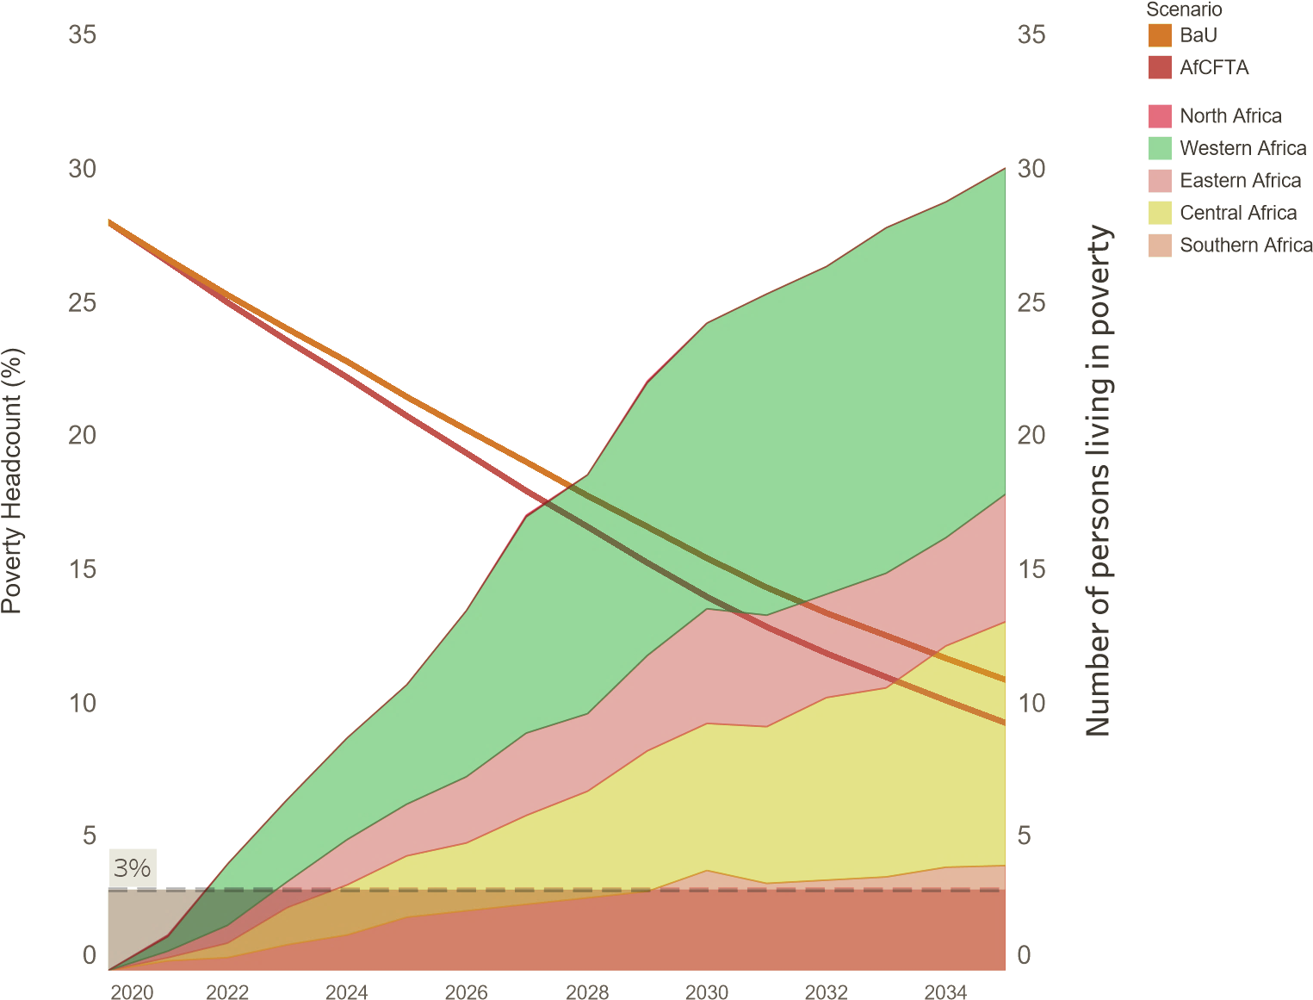

**Moderate Poverty ($5.20 a day 2011 PPP) (% of population)**

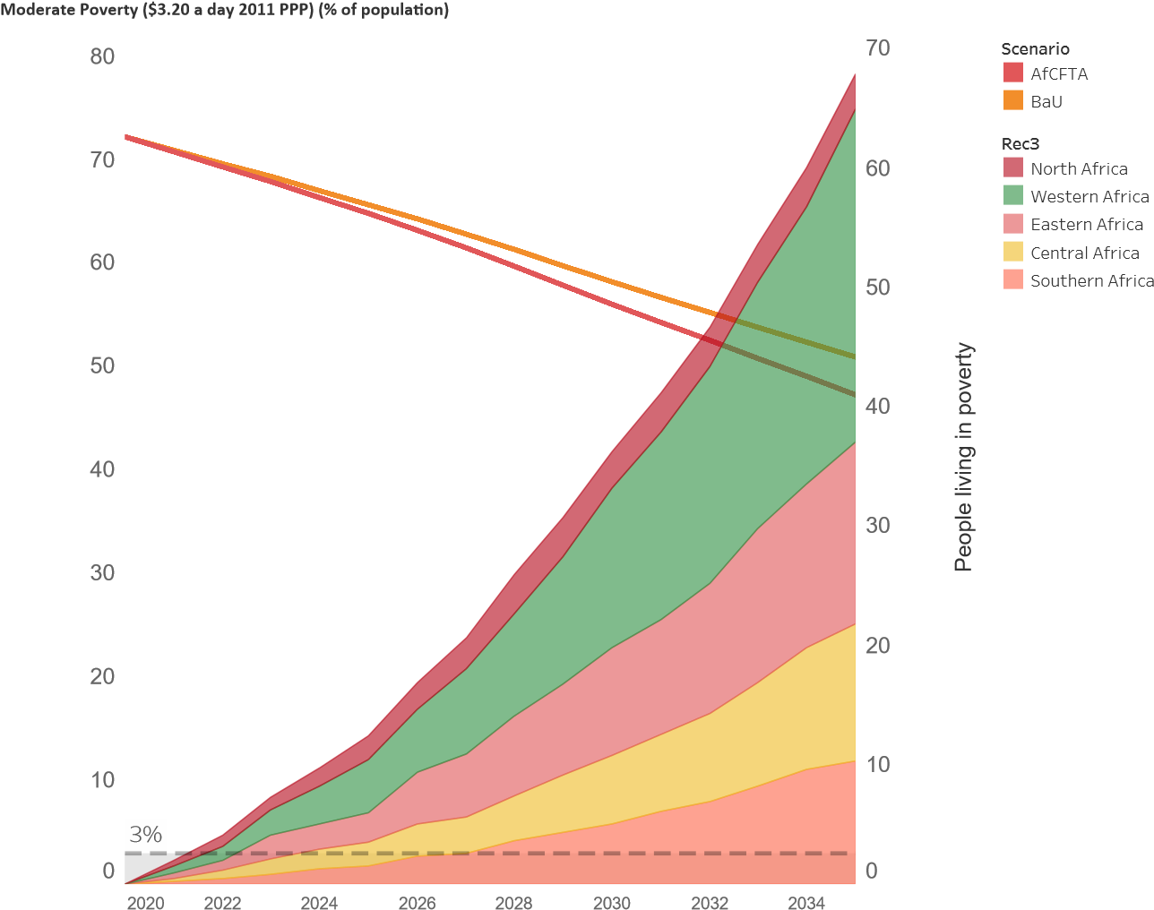

**Source:** World Bank Group Estimates, 2020

**4.0 CONCLUSION**

In spite of the ravaging impact of COVID-19 on the economies of many African countries, the optimism relating to the success of AfCFTA is still very high. The recent survey undertaken by the Ghana Statistical Service (GSS) points out that about 76 percent of firms in Ghana are optimistic about the prospects and transformational impact of AfCFTA. ([www.myjoyonline.com/76-of-firms-optimistic-afcfta-will-transform-their-business/amp/](http://www.myjoyonline.com/76-of-firms-optimistic-afcfta-will-transform-their-business/amp/))

In this regard, it is expected that the impact of the Agreement need to be felt at the macro and micro economic levels, particularly with increased job opportunities as projected by the ADB's African Economic Outlook of 2018, which stated that the AfCFTA would create over 7.5 million additional employments in Sub-Saharan Africa[14].

The exploratory study of the various African and Sub-Saharan economies as shown in this paper is an indication that governments must endeavour to create the enabling environment for business to thrive and reduce poverty. With increased intra-African trade, it is expected that firms will be able to enter or export into new markets with value-addition products. This will boost the export levels of African economies, and particularly Ghana which has over the long years relied on traditional cash crops and raw material exports.  According to a UNECA analysis, by 2040, trade in agriculture and food items could see increases ranging from 20% to 30%, while a substantial increase in energy and mining items could rise from 5% to 11%. Africa's population is rising substantially, and the increasingly youthful workforces are seeking for employment.

The statistics of youth unemployment in southern African countries such as Eswatini (56 percent), Botswana (36 percent), Namibia (46 percent) and South Africa, 54 percent, is not too different to what pertains in Sub-Saharan Africa. It is therefore imperative that strategies are implemented to ensure that wage-earning blue and white collar jobs are consistently created to address this key issue. AfCFTA has indeed come to stay. The agreement will not only boost Africa's position and voice within the global trading system, but it will unite trade interests and enhance intra-continental commerce. It is hoped that by 2063, when African political unity is a century old, we would be recounting the many success stories of the AfCFTA.

**5.0 GITFIC RECOMMENDATION**

1. Governments must focus on enabling a seamless and inclusive transition by encouraging competitive labor markets, improving intra-country connectivity, and guaranteeing strong macroeconomic policies and a business climate that is attractive for foreign direct investment (FDI).
2. Policymakers must maintain a periodic assessment on the distributional effects of AfCFTA on industries, employment and the micro private sector.
3. Cognisance of the Ghana government's national program of boosting intra-African trade (BIAT), it is recommended that the various working groups would strengthen collaboration to harness maximum benefits under AfCFTA.
4. Trade facilitation should be a key focus of the government of Ghana. It is recommended that the bureaucracies relating to customs and administrative entry processes, trade barriers, as well as sanitary and phytosanitary measures are reduced to the barest minimum.
5. Ghana should improve direct and policy support to local infant firms so that they are not unfairly disadvantaged under the liberalized scheme of AfCFTA.

**REFERENCE**

Abrego, L., M. A. Amado, T. Gursoy, G. P. Nicholls, and H. Perez-Saiz. (2019). “African Continental Free Trade Agreement: Welfare Gains Estimates from a General Equilibrium Model.” IMF Working Paper 19/124, International Monetary Fund, Washington, DC.

African Economic Research Consortium (AERC), (2013) Research Paper 113 (Nairobi).

Anyanwu, J. C. (2014). Does Intra-African Trade Reduce Youth Unemployment in Africa? African Development Review, 26(2), 286-309.

Bhorat, H., Kanbur, R., Rooney, C., & Steenkamp, F. (2017). DP12073 Sub-Saharan Africa's Manufacturing Sector: Building Complexity

Bourguignon, F., M. Bussolo, and L. Pereira da Silva (eds) (2008) "The Impact of Macroeconomic Policies on Poverty and Income Distribution -Macro-Micro Evaluation Techniques and Tools", The World Bank and Palgrave Macmillan, Washington DC, New York.

Bussolo, M., De Hoyos, R., and Medvedev, D. (2010) ―Global Poverty and Distributional Impacts; The GIDD Model‖, in Anderson, K., Cockburn, J., and Martin, W. (editors) Agricultural Price Distortions, Inequality, and Poverty,The World Bank.

International Labour Organization (ILO). 2016. “Women and Men in the Informal Economy: A Statistical Picture.” Geneva.

Perez-Saiz, H. Forthcoming. (2019). “Trade and the Skill Premium: The Case of the African Continental Free Trade Agreement.” IMF Working Paper, International Monetary Fund, Washington, DC.

The World Bank Group, (2020). The African Continental Free Trade Area: Economic and Distributional Effects. Washington, DC: World Bank. Doi: 10.1596/978-1-4648-1559-1. License: Creative; Commons Attribution CC BY 3.0 IGO

van der Mensbrugghe, Dominique (2006) ―The LINKAGE Model Technical Documentation.‖ Washington, DC: World Bank.

World Bank. (2018). Negotiating Trade in Services: A Practical Guide for Developing Countries. New York: World Bank.

1. The World Bank Group, (2020). The African Continental Free Trade Area: Economic and Distributional Effects. Washington, DC: World Bank. Doi: 10.1596/978-1-4648-1559-1. License: Creative; Commons Attribution CC BY 3.0 IGO
2. United Nations. (1995). *United Nations World Summit (Copenhagen) for social development. programme of action*, Chapter 2. New York: United Nations
3. Abrego, L., M. A. Amado, T. Gursoy, G. P. Nicholls, and H. Perez-Saiz. (2019). “African Continental Free Trade Agreement: Welfare Gains Estimates from a General Equilibrium Model.” IMF Working Paper 19/124, International Monetary Fund, Washington, DC.
4. Anyanwu, J. C. (2014). Does Intra-African Trade Reduce Youth Unemployment in Africa? African Development Review, 26(2), 286-309.
5. The World Bank Group, (2020). The African Continental Free Trade Area: Economic and Distributional Effects. Washington, DC: World Bank. Doi: 10.1596/978-1-4648-1559-1. License: Creative; Commons Attribution CC BY 3.0 IGO
6. Bhorat, H., Kanbur, R., Rooney, C., & Steenkamp, F. (2017). DP12073 Sub-Saharan Africa's Manufacturing Sector: Building Complexity
7. International Labour Organization (ILO). 2016. “Women and Men in the Informal Economy: A Statistical Picture.” Geneva.
8. African Economic Research Consortium (AERC), (2013) Research Paper 113 (Nairobi).
9. Bourguignon, F., M. Bussolo, and L. Pereira da Silva (eds) (2008) "The Impact of Macroeconomic Policies on Poverty and Income Distribution -Macro-Micro Evaluation Techniques and Tools", The World Bank and Palgrave Macmillan, Washington DC, New York.
10. Bussolo, M., De Hoyos, R., and Medvedev, D. (2010) ―Global Poverty and Distributional Impacts; The GIDD Model‖, in Anderson, K., Cockburn, J., and Martin, W. (editors) Agricultural Price Distortions, Inequality, and Poverty,The World Bank.
11. van der Mensbrugghe, Dominique (2006) ―The LINKAGE Model Technical Documentation.‖ Washington, DC: World Bank.
12. Perez-Saiz, H. Forthcoming. (2019). “Trade and the Skill Premium: The Case of the African Continental Free Trade Agreement.” IMF Working Paper, International Monetary Fund, Washington, DC.
13. World Bank. (2018). Negotiating Trade in Services: A Practical Guide for Developing Countries. New York: World Bank.
14. The World Bank Group, (2020). The African Continental Free Trade Area: Economic and Distributional Effects. Washington, DC: World Bank. Doi: 10.1596/978-1-4648-1559-1. License: Creative; Commons Attribution CC BY 3.0 IGO